GUIDE TO COMPLETING DIRECT PAYMENTS MONITORING SHEETS

How to Complete a Monitoring Sheet
Direct Payments Monitoring Sheets should be completed for each calendar month and should be submitted to the Adult Social Work Department on a monthly basis with all relevant paperwork.

Paper copies of monitoring sheets are provided, however if you would prefer you can complete the form using excel and submit through email. The benefit of using excel is that all the calculations are completed for you. If you would like to use the excel version of the monitoring sheet please contact the Direct Payments Admin Support Worker with your email address.

The following details are to be input to the monitoring sheet as shown below:

1) The name of the Direct Payments Recipient
2) The month the transactions correspond to
3) The balance carried forward from the previous monitoring form.
4) Transaction details should be completed as below. If payment was made by cheque please detail the cheque number here.

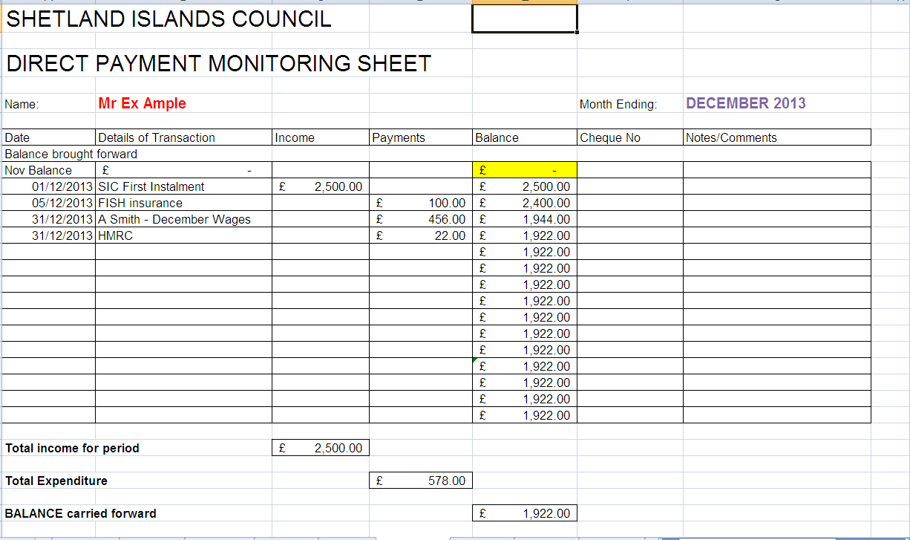

If you complete the sheet using excel the calculations will automatically be done for you. However if you use paper monitoring sheets you will need to calculate the new balance after inputting each income / payment. You will also need to calculate the following three figures (as shown at the bottom of the monitoring form):

Total Income for Period - Do this by adding all figures detailed in the Income Column
Total Expenditure – Do this by adding all figures detailed in the Payments Column
Balance carried forward – Deduct the Total Expenditure figure from the Total Income figure.

Other Relevant Paperwork
All other relevant paperwork should be submitted with the monthly monitoring sheet. Relevant paperwork includes:

- Bank statements / transaction print outs
- Any invoices or receipts
- Timesheets or copies of wage slips

Please ensure that all paperwork is provided.

Please Note
Any transaction through the Direct Payments bank account must be detailed on the monitoring sheet, therefore please detail any interest received on the account on the monitoring sheet.

When recording wage transactions on the monitoring sheet please detail what month the wage corresponds to, this helps maintain clarity at the end of the financial year.

Any Problems
If you have any problems completing the monitoring sheets please contact the Direct Payments Admin Support Worker or your Care Manager.

Self Directed Support Officer’s Contact Details:
Theresa Wadley Tracey Work
Adult Social Work Adult Social Work
Grantfield Grantfield
Lerwick Lerwick
ZE1 0NT ZE1 0NT
01595 744414 01595 744400
directpaymentsccare@shetland.gov.uk directpaymentsccare@shetland.gov.uk

